PROGRAMMING II

**Exercise 1 (OOP)**

Example 1 – Bird

States:

1. Type : String

2. Colour : String

3. Size : char

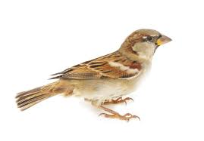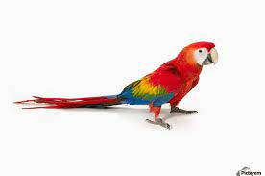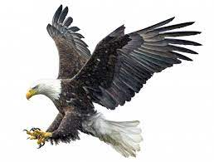

Behavior:

1. fly (boolean fly) : void

2. eat (String eat) : void

3. sleep (boolean sleep) : void

4. layegg(int eggNum) : void

Type: Sparrow

Colour: Brown

Size: S

Type: Parrot

Colour: Red, yellow, blue

Size: M

Type: Eagle

Colour: Black, white

Size: L

Class: Bird

Example 2 – Battery

States :

1. Brand : String

2. Voltage : double

3. Size : String

Class: Battery

Behavior:

1. Provide energy (boolean provide) : void

2. Convert energy to electrical (boolean convEn) : void

3. Store energy (int volt) : void

Brand: Panasonic

Voltage: 1.5 volts

Size: AA

Brand: Energizer

Voltage: 4.5 Volts

Size: 3LR12

Brand: Duracell

Voltage: 12 volt

Size: A23

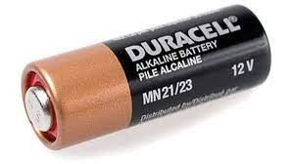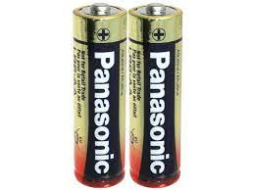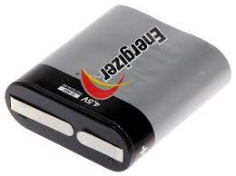

Example 3 – Bottle

States:

1. Brand : String

2. Material : String

3. Shape : String

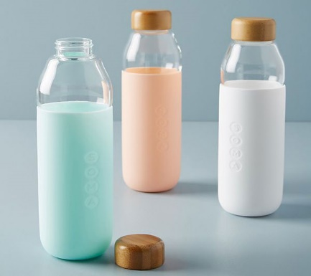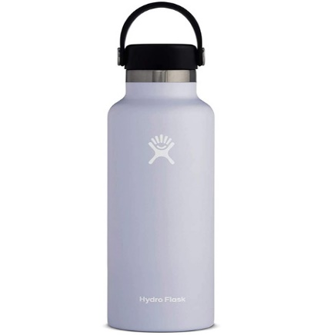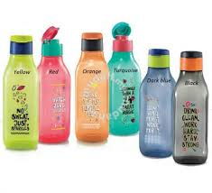

Behavior:

1. Keep liquid (boolean liquid) : void

2. Measure liquid level (int level) : void

3. Easy to carry (boolean carry) : void

Brand: Soma

Material: Glass

Shape: Cylinder

Brand: Hydro Flask

Material: Steel

Shape: Cylinder

Brand: Tupperware

Material: Plastic

Shape: Rectangle

Class: Bottle

Example 4 – Cat

States:

1. Breed : String

2. Colour : String

3. Size : String

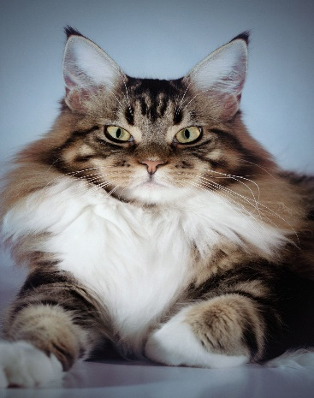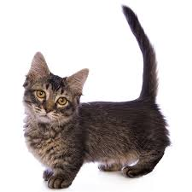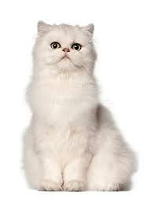

Behavior:

1. Eat (boolean eat) : void

2. Sleep (boolean sleep) : void

3. Run (boolean run) : void

4. Climb (Boolean climb) : void

Breed: Maine Coon

Colour: Brown, white

Size: Big

Breed: Munchkin

Colour: Black, white

Size: Small

Breed: Persian

Colour: White

Size: Medium

Class: Cat

Example 5 – Watch

States:

1. Type : String

2. Material : String

3. Brand : String

Class: Watch

Behavior:

1. Identify time (double indtime) : void

2. Set alarm (double alarm) : void

3. Set timer (double timer) : void

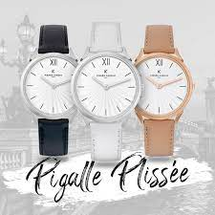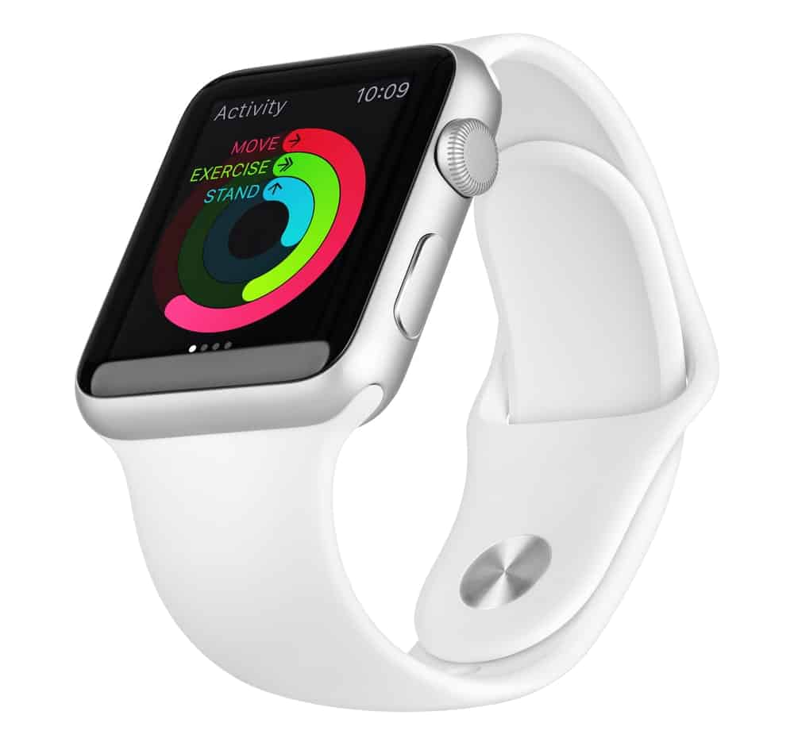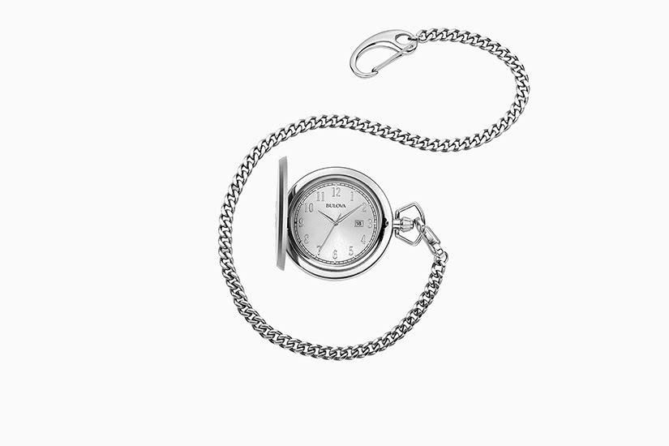

Type: Wrist watch

Material: Leather

Brand: Pierre Cardin

Type: Smart watch

Material: Rubber

Brand: Apple

Type: Pocket watch

Material: Steel

Brand: Bulova